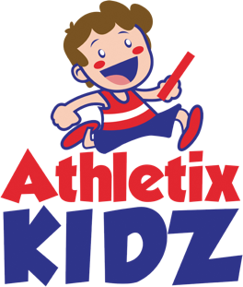

DESIGN YOUR OWN

ATHLETIX KIDZ

RUNNING VEST

**Make it bright, colourful and funky**

Back

Front

**Name: ………………………**